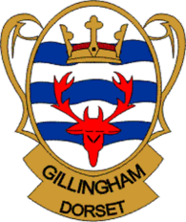
GILLINGHAM TOWN COUNCIL

5 YEAR ACTION PLAN

FY2025/26 – 2030/31
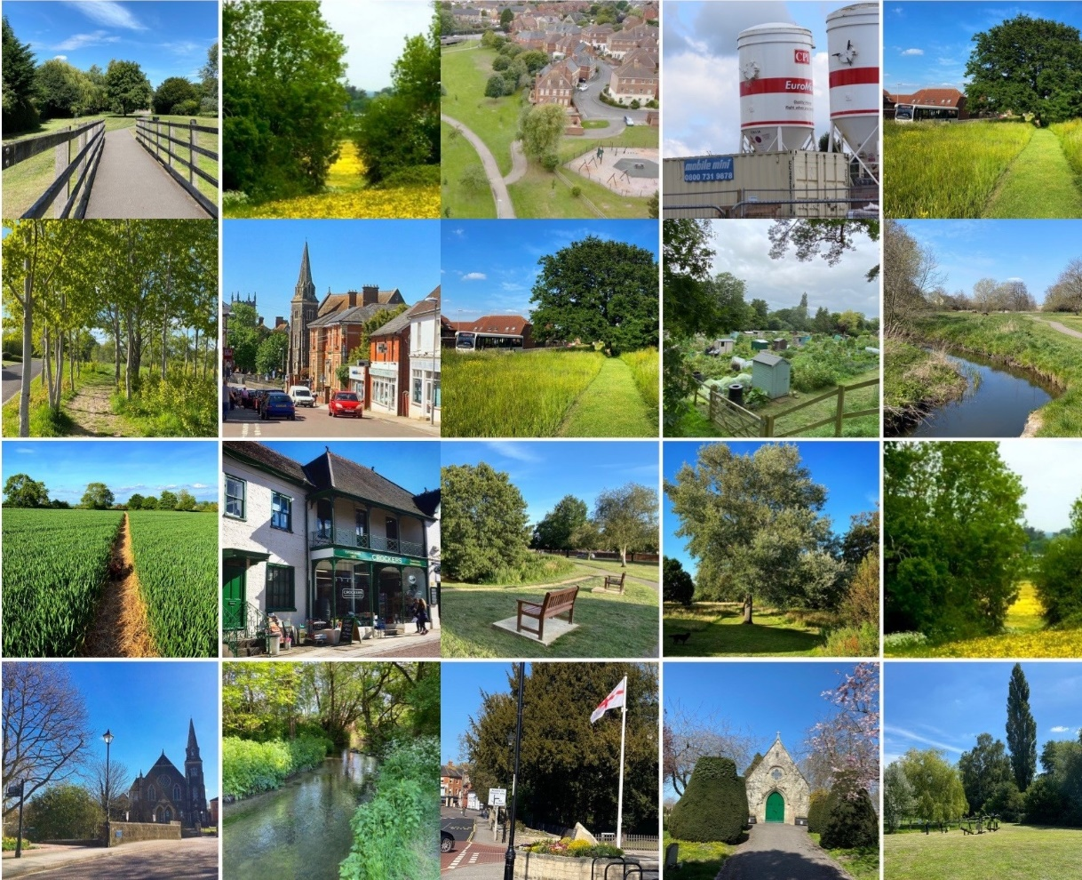

CONTENTS

- Introduction …………………………………………………………………….………………………………………….. Page 3
- Overview ………………………………………………………………….…………………………………………………. Page 3
- Governance ………………………………………………………….……………………………………………………… Page 5
- What we Do ………………………………………………………….…………………………………………………….. Page 6
- Our Vision ………………………………………………………………….……………………………………………….. Page 8
- Our Priorities ……………………………………………………………….……………….…………………………….. Page 8
- Five Year Action Plan …………………………………………………………….……………………………………. Page 9
- Monitor and Review …………………………………………………………….…………………………………….. Page 23

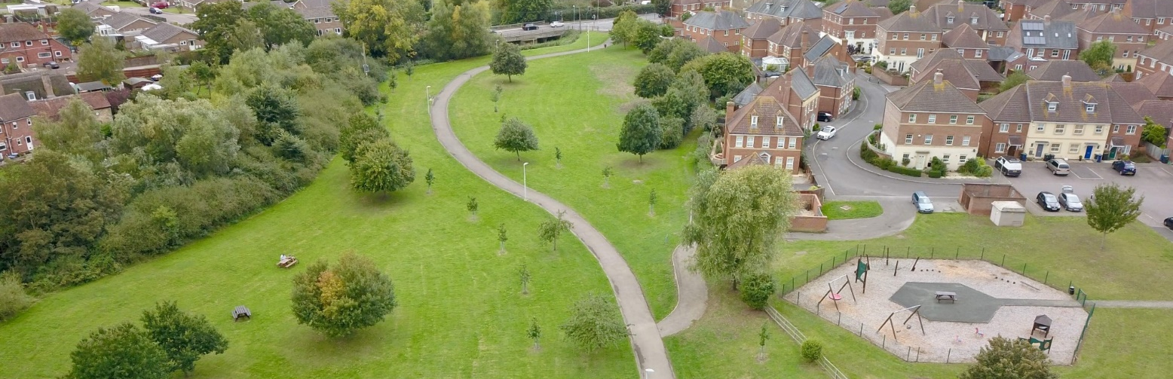

Introduction

A 5-year action plan is a statement of Gillingham Town Council’s vision, objectives and projects that the council intends to accomplish over the next five years. This plan is designed to address the needs of the community and ensure sustainable development.

The plan is flexible, and we build in contingencies to ensure that we can respond to unplanned events, emerging risks or changing priorities. The plan informs the annual budget setting process, which ultimately leads to the Council Tax precept. It is a ‘live’ document which the Town Council updates at least annually, enabling it to track and monitor its progress against the key priorities.

Overview

Gillingham is Dorset’s most northerly town, located on the confluence of three rivers - the Stour, Shreen Water and Lodden. The town currently has a population of just under 12,000 and acts as a key service centre for a wide catchment area. The A303 is a major national trunk road, lying 6km to the north. The town has a station on the London to Exeter railway line.

Gillingham has several heritage assets, including the Grade I listed church of St Mary the Virgin in the town centre and the four conservation areas of Gillingham, Wyke, Colesbrook and Milton-on-Stour. The Gillingham Neighbourhood Plan (2016-2031) was ‘made’ (adopted) in July 2018. It contains some policies to influence development in the town.

Gillingham Town Council is politically independent. It has eighteen councillors who represent the six wards of Town North, Town South, Wyke, Ham, Milton-on-Stour and Rural, and 16 members of staff.

The role of the Town Council is to ensure Gillingham is a thriving community and a healthy, vibrant and attractive place in which to work, live and visit. The Town Council does this by working collaboratively, not only as an ambitious and committed team of councillors and staff but also with a range of external strategic partners.

The Town Council is committed to providing excellence in the services and facilities which it delivers, aiming to be responsive, innovative, visible, accessible and straightforward in our approach.

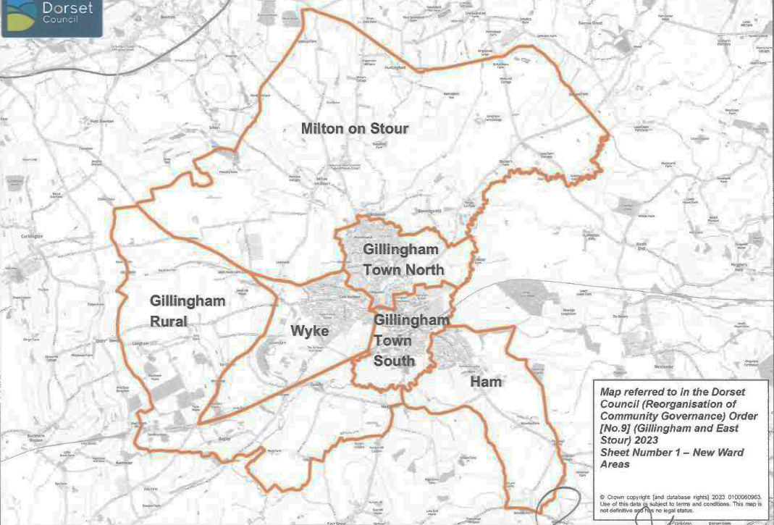
Gillingham Town Council Wards

Governance

The governance of the Town Council plays a crucial role in local democracy and community development. Gillingham Town Council is responsible for making decisions that directly impact residents' lives. Effective governance requires transparency, accountability and active community engagement to ensure that the Council reflects the interests of its residents. Gillingham Town Council encourages public participation in meetings and decision-making processes, and a period of time is set aside for public participation at the beginning of Full Council and Standing Committee meetings. These meetings are held at the Town Hall on a Monday evening. A calendar of meetings is available to view on the Town Council’s website and on public noticeboards.

Each May at the Annual Council Meeting a Mayor and Deputy Mayor are elected, committee memberships are agreed and representatives to other bodies are selected. The Mayor is the Chairman of the Council and the Council’s ambassador at public, civic and ceremonial events.

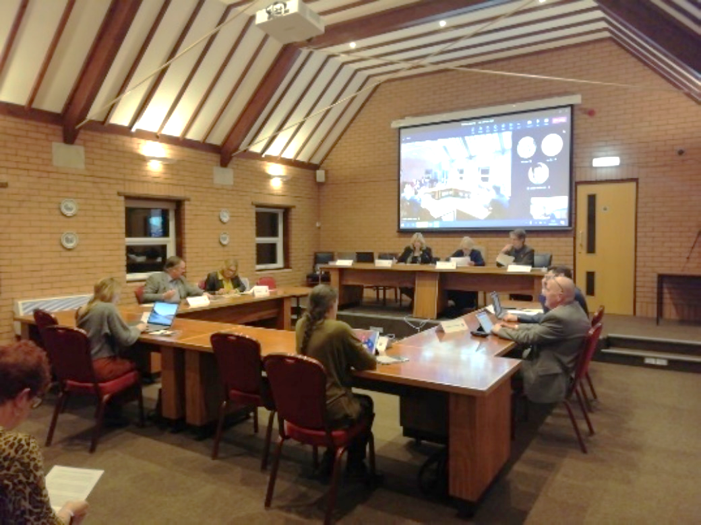
The Town Council has the following Standing Committees:

- General Purposes
- Planning
- Human Resources
- Finance and Policy

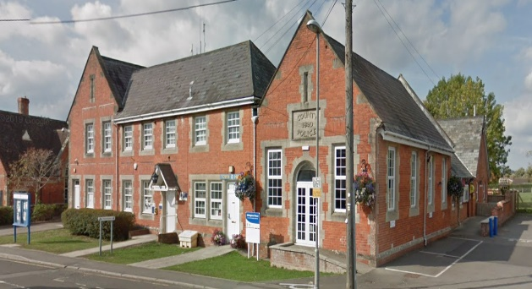
What We Do

Councillors and staff strive to ensure that all Council operations are delivered in the most effective and efficient manner and comply with regulation and best practice. This 5-year plan focuses on new projects or major pieces of work requiring new or significant resource allocation.

In the background, the day-to-day operations of the Council continue to include:

- Efficient operation and governance of the Council’s business – Council meetings, elections, policies, finance and budgeting, staff recruitment and management, administration, customer service etc
- Legal compliance
- Communication with the community – hosting the Town Council websites and social media feeds, responding to requests for information, consultations, promoting events etc
- Management of the Council’s assets – land, buildings, plant and equipment

Gillingham Town Council is currently responsible for:

- 28 hectares (71 acres) of public open space which are maintained to a high standard and have achieved Green Flag accreditation
- 2.68 hectares (6.60 acres) of grassed roadside verges
- Over 700 mature trees and over 800 new trees
- Emptying litter bins in various locations around the town (Dorset Council is responsible for town centre street cleaning)
- Various buildings, including the Town Hall, Roman Court Workshops, the Cemetery Chapel and the public toilet
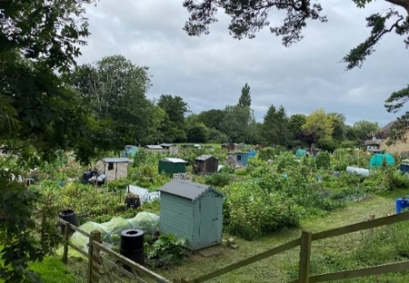
- Various gardens, including the Garden of Remembrance
- The cemetery
- The closed churchyard at the Parish Church of St. Mary the Virgin
- The Town Meadow
- 19 play areas, 1 skatepark and 2 outdoor gyms including Hardings Park
- 2 war memorials
- A speed indicator device
- Town centre CCTV
- 3 bus shelters
- 2 allotment sites

All buildings, play areas, vehicles, equipment and other areas of responsibility are managed in accordance with a schedule of maintenance which accounts for the life cycle of an item, in many cases exceeding 5 years.

This process incorporates the maintenance and replacement of equipment and buildings and the financial costs over time. The Town Council uses annual financial accruals to save the funds to carry out maintenance when required.

The Town Council allocates the responsibility for developing and delivering the various plans to specific sub-committees.

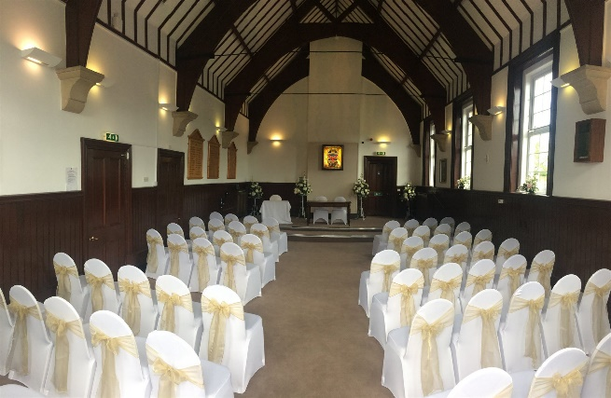
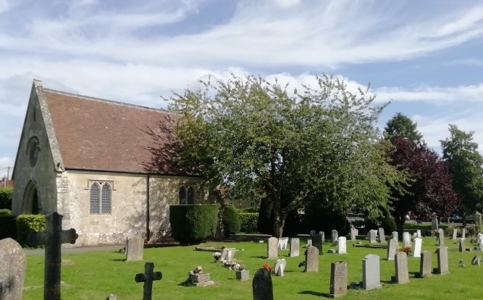
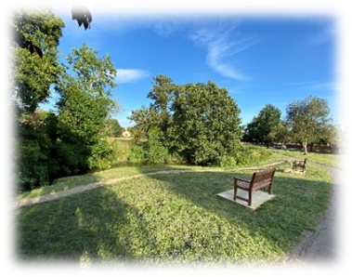
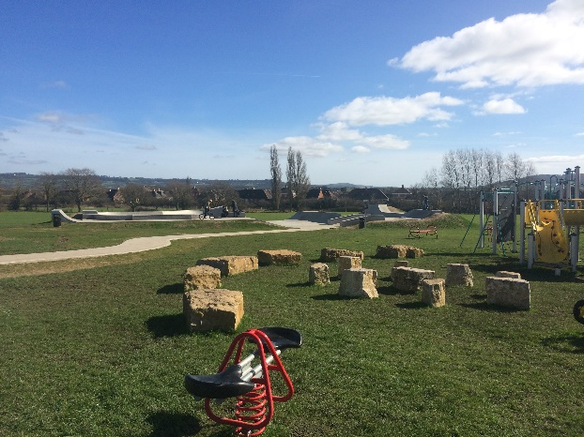
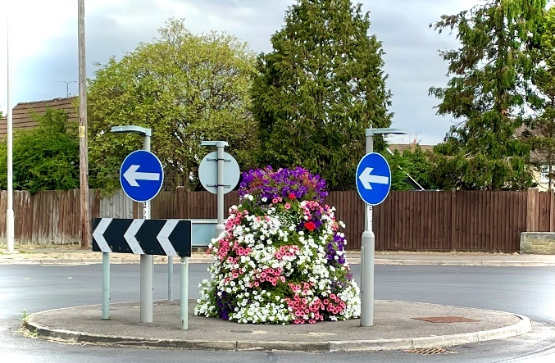
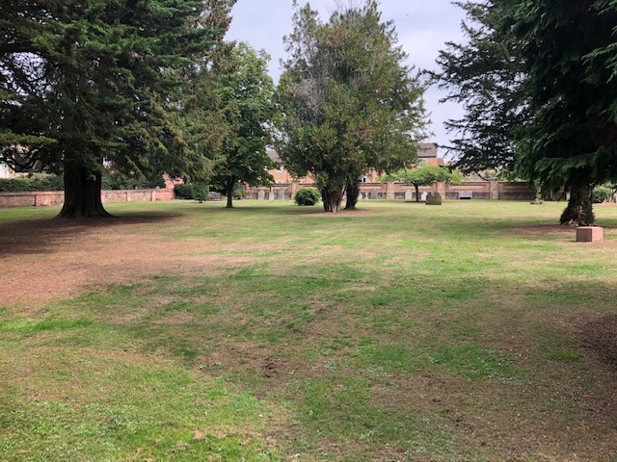

Our Vision

To be a modern Town Council committed to creating a vibrant and attractive town where people want to live, work and visit.

A vision for Gillingham was developed with the local community at a series of community events and consultations for the production of the Gillingham Neighbourhood Plan. The Town Council’s vision is based around the vision of the Gillingham Neighbourhood Plan.
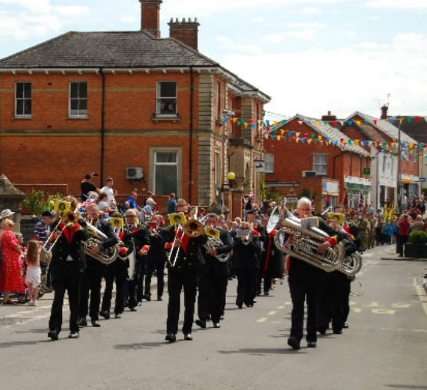
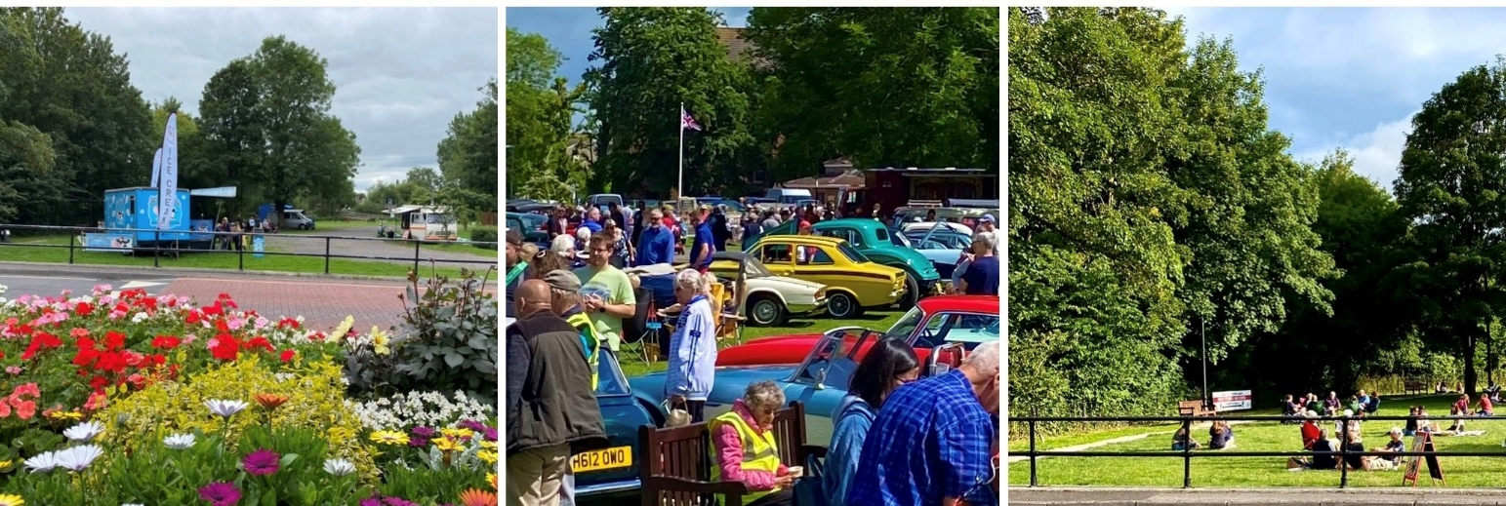

Our Priorities (in no particular order)

- Improving our Parks and Open Spaces
- Improving Community Wellbeing
- Developing Gillingham’s Future
- Creating Safer Communities
- Developing a Sustainable Built Environment
- Developing a Sustainable Local Economy

5-Year Action Plan

The Town Council agreed to produce a 5-year plan to:

- Promote transparency – being clear what the Town Council priorities are and what actions will be delivered over the plan period 2025 to 2030
- Set the priorities of the Town Council in a strategic context
- Provide a basis for securing funding – whether through the local precept, revenue generation or funding bids
- Co-ordinate the Town Council’s work with others and generate productive collaboration with partners
- Provide the basis for oversight by councillors and others
- Ensure the Town Council gets best value for its residents

As developments are planned and during the latter parts of building, external funding including S106 developer contribution funding can become available. These funds are negotiated during the development stage and can contribute to the facilities of the town.


S106 funds are provided by the developer to Dorset Council and can be allocated to projects developed by the Town Council. Some are identified in the funding column of the project in the table on the next page.

We have looked at the strategic development and growth of the town and have noted the S106 developer funding already agreed for developments that have planning permission. We know that this funding is dependent upon housing delivery and timings cannot be quantified but we are reassured that, in time, funding is likely to be made available to support specific requirements in the town.

The plan identifies the financial year(s) in which the work could be achieved, identifies the potential source of funding and provides commentary in the notes where appropriate.

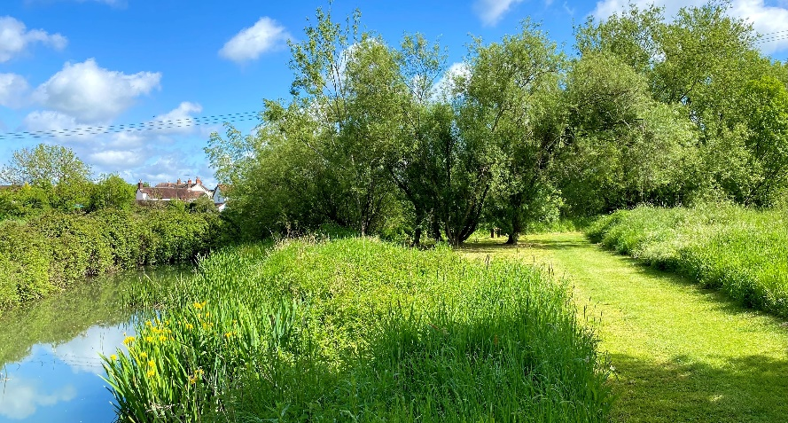
Improving our Parks and Open Spaces

Improving our parks and open spaces is essential for creating vibrant, sustainable environments that benefit both residents and local ecosystems. By investing in green spaces, we can promote physical health, mental wellbeing and community engagement while also supporting biodiversity. Key initiatives include upgrading park amenities, planting more trees, improving accessibility, and creating spaces for recreational activities and social interaction. These enhancements will create a deeper connection between people and nature, making our neighbourhoods more resilient and enriching for everyone.

Project | Responsible Working Group | Funding Source | Delivery Date | Progress Report
Garden of Remembrance
Landscaping, creation of accessible paths and flowerbeds. Sensory Garden | Estate Management | GTC  S106  Additional funding required | 2026 – 2029 | Additional funding required – waiting for S106 funds to be made available. Further grant funding to be sought
Closed Churchyard, St Mary’s Church
Repairs to retaining wall | Estate Management | GTC | 2025/26 | In talks with the church architect
Resurfacing of paths | Estate Management | GTC | 2025/26
Allotments
Creation of additional allotments in the southern extension in partnership with developers | Allotments and Burials | Developer funding | 2028/29 | Part of the southern extension delivery by developers
Public Open Space
Rolls Bridge - improvements to path between Rolls Bridge and Jubilee Fields. Creation of a bridge and divert footpath | Estate Management | GTC & S106 | 2026/27 | Surveys required
Fernbrook - resurfacing improvements to path – Phase 1 | Estate Management | GTC | 2025/26 | Funding in budget 25/26  Additional work will be carried out to link the path to the new development at a later date.
King John Road - additional play equipment | Estate Management | GTC | 2025/26 | Funding in budget 25/26
Adoption of new play trail at Lodden Lakes, Phase 2 | Estate Management | No commuted sum from developer has been identified | 2026/27
Upper Lodden - resurfacing improvements to path | Estate Management | GTC | 2025/26 | Funding in budget 25/26
Ham Farm - path repairs and improvements | Estate Management | GTC & S106 | 2026/27
Lodden Valley (Ham Farm) - creation of hard surface path between the footbridge and St Mary's School | Estate Management | GTC  S106, additional funding required | 2026/27
Creation of community orchards, in partnership with developers | Estate Management | Developer funded | 2027/28 | Delivery by developers
Creation of community wood by GANG - in flood zone adjacent to proposed employment area southern extension | Estate Management | External funding | 2027/28
Fernbrook – create new play area in partnership with developer | Estate Management | GTC & Developer | 2027/28
Lodbourne play area - update | Estate Management | GTC | 2028/29

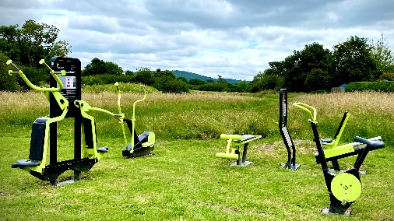
Improving Community Wellbeing

Community wellbeing is the foundation of a thriving, connected, and resilient society. It helps reduce social inequalities, strengthen relationships, and create a sense of belonging, ultimately leading to a healthier, more vibrant community for all.
Project | Responsible Working Group | Funding Source | Delivery Date | Progress Report
Play Areas
Hardings Park - Masterplan Framework required | Sports & Leisure | GTC, S106  Additional grant funding | 2025/26
Engage with sports groups to provide additional sports provision | Sports and Leisure | S106, GTC & external funding | 2025/26
Hardings Park – phased replacement of play equipment | Estate Management | GTC | 2025/26 | Budget 25/26
Hardings Park - creation of pump track | Sports & Leisure | GTC & S106  Additional funding required | 2027/28
Hardings Park - creation of sports courts | Sports & Leisure | GTC & S106 Additional funding required | 2027/28
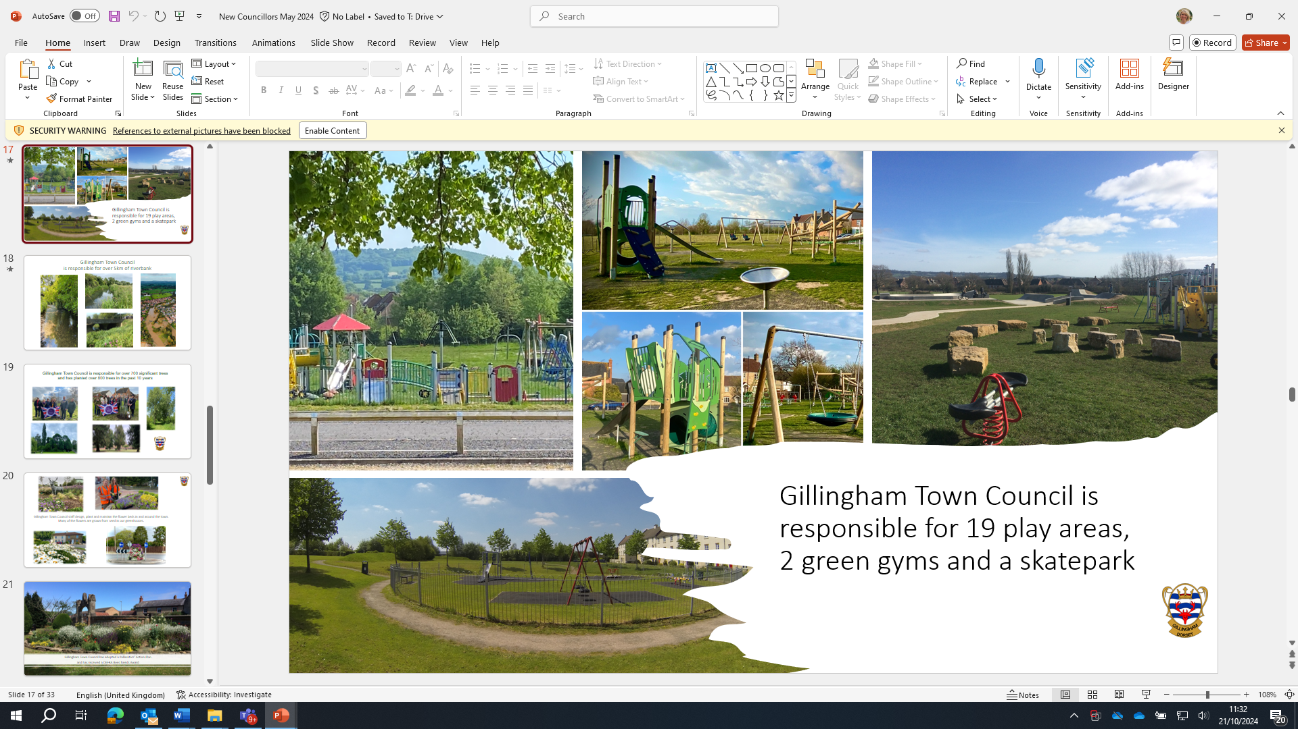
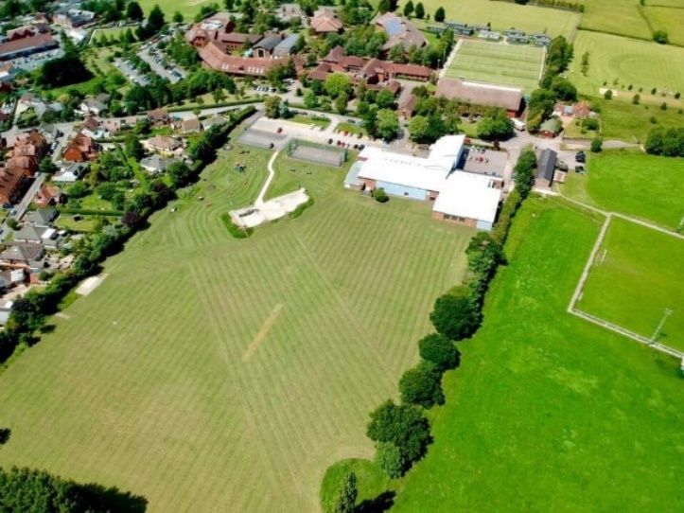

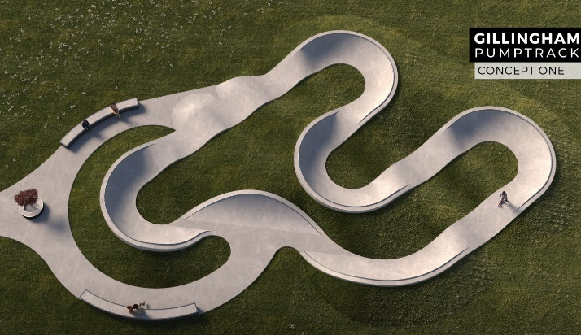
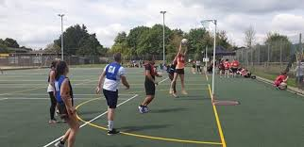

Developing Gillingham’s Future
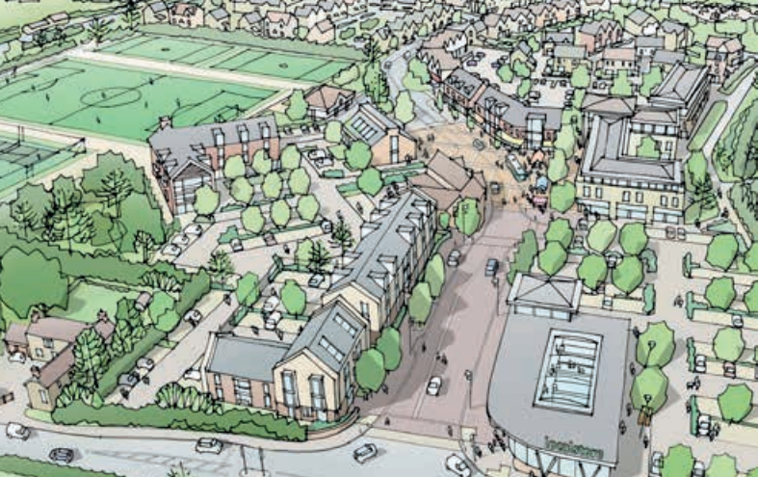
Gillingham’s future lies in its ability to evolve while preserving its unique character and community spirit. By investing in sustainable development, modern infrastructure and economic growth, we can create a town that thrives both socially and economically. Key areas of focus include improving public services, enhancing transportation networks, creating new job opportunities and supporting local businesses. Additionally, developing a sense of community through cultural and recreational projects will ensure Gillingham remains a vibrant place to live, work and visit. By planning thoughtfully, we can build a resilient and prosperous future for Gillingham, making it a model for sustainable development and community engagement.

Project | Responsible Working Group | Funding Source | Delivery Date | Progress Report
Develop a Market Town Strategy | Market Town Strategy | GTC | 2025/26
Purchase a site for a new burial ground and associated costs | Allotments and Burials | GTC & S106 | 2025/26 | In progress
Creation of a new burial ground | Allotments and Burials | GTC & S106 | 2025/27
Monitor and review the Neighbourhood Plan | Neighbourhood Plan | GTC and external funding from Locality | 2025/26
Complete a Conservation Area Appraisal document and Consultation for Gillingham Conservation Area | Conservation Area | GTC | 2026/27
Complete an appraisal of the Milton-on-Stour Conservation Area | Conservation Area | GTC | 2028/29
Sports Pavilion (CG Fry) | Sports and Leisure | Developer Funding  GTC |  | Initial discussions have taken place. Delivery will be by developers
Sports Pitches (CG Fry) | Sports and Leisure | Developer Funding  GTC |  | Initial discussions have taken place
Sports Pavilion (Redrow) | Sports and Leisure | Developer Funding |  | Delivery by developers
Sports Pitches (Redrow) | Sports and Leisure | Developer Funding |  | Delivery by developers
Community Centre (Redrow) |  | Developer Funding  GTC |  | Delivery by developers
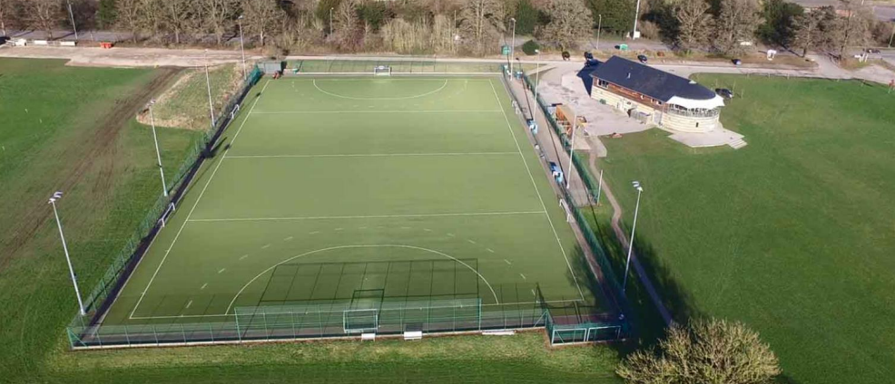

Image of The SSWSC Clubhouse, Salisbury

Creating Safer Communities

A safer community is one where every resident feels secure and valued, and where trust between the public, law enforcement and local organisations is strong. Working together, we will create a more resilient, peaceful and united community where everyone feels safe and supported. The Council considers crime and disorder implications in all its decisions and does all that it reasonably can to reduce crime and disorder.
Project | Responsible Working Group | Funding Source | Delivery Date | Progress Report
CCTV monitoring to migrate to Dorset Council | CCTV | Dorset Police & Crime Commissioner | 2025/26
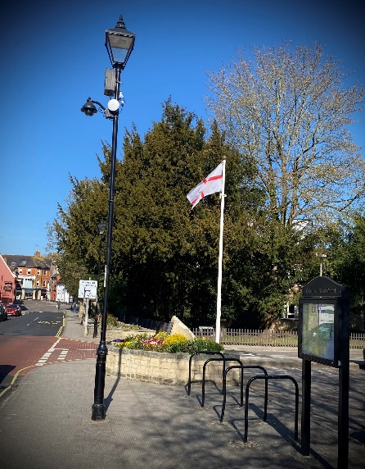
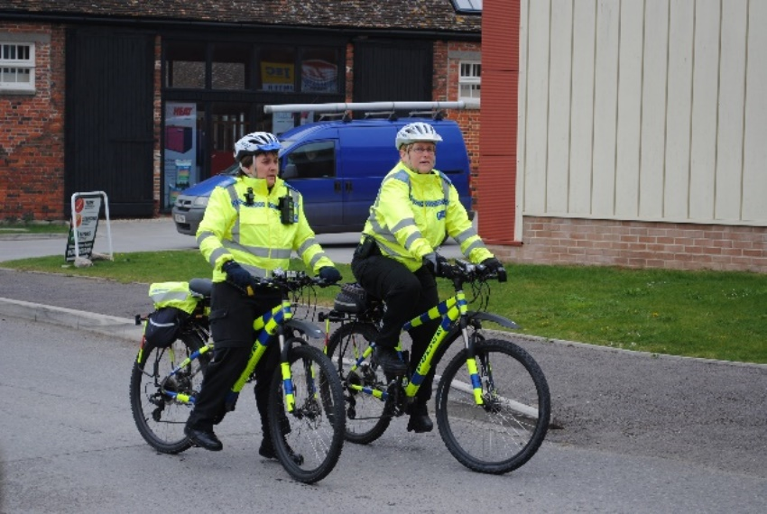

Developing a Sustainable Built Environment
Creating a sustainable built environment is crucial for addressing the challenges of climate change. By integrating green building practices, energy-efficient technologies, and eco-friendly materials, we can design spaces that minimise environmental impact while enhancing quality of life. Key strategies include adopting renewable energy sources, promoting water conservation, improving waste management, and ensuring buildings are designed for longevity and adaptability. Additionally, urban planning that prioritises walkability, green spaces, and public transportation will help reduce carbon footprints and improve healthier communities. Developing a sustainable built environment is not just about construction - it's about creating a future where people and the planet can thrive together.

Project | Responsible Working Group | Funding Source | Delivery Date | Progress Report
Buildings
Town Hall PV Panels | Property Management | GTC | 2025/26
Town Hall Replacement lighting to environmentally friendly improvements | Property Management | GTC | 2026/27
Cemetery Shed - improvements to water service area | Allotments and Burials | GTC | 2025/26
Chantry Community Office – replacement flooring | Property Management | GTC | 2026/27
Adoption of new bus shelters | Property Management | GTC | 2026/27
Town Hall – structural work and landscaping at the front of the building | Property Management | GTC | 2027/28
Partnership Working
Parking improvements for Gillingham Station |  | Developer funding
Work with NDRFC on a safe pedestrian route to the rugby club |  | Developer Funding
Improvements to Footpath 64/47 & 64/48 to the west of the station, including the pedestrian bridge over the River Stour |  | Developer Funding

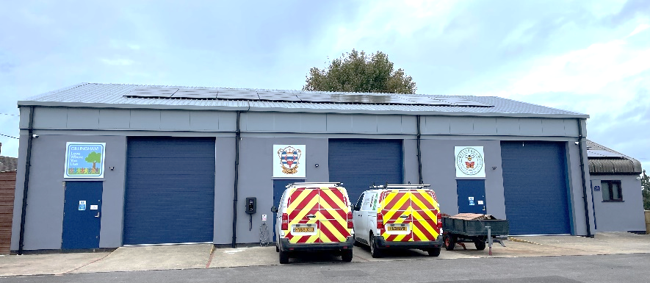

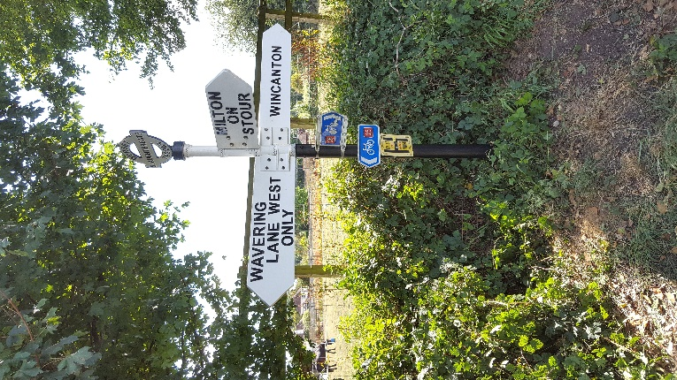
Developing a Sustainable Local Economy

A sustainable local economy is one that balances economic growth with environmental stewardship and social equity. By supporting local businesses, encouraging innovation and promoting eco-friendly practices, we can create a resilient economy that benefits both people and the planet. Building a sustainable local economy ensures long-term prosperity while reducing environmental impact and creating a more equitable and self-sufficient future for all.

Project | Responsible Working Group | Funding Source | Delivery Date | Progress Report
Review town centre signage in consultation with DC Highways | Town Centre Signage | GTC & Dorset Council | 2025/26
Cultural and Community Centre |  | Developer funding
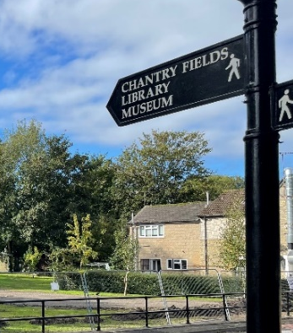
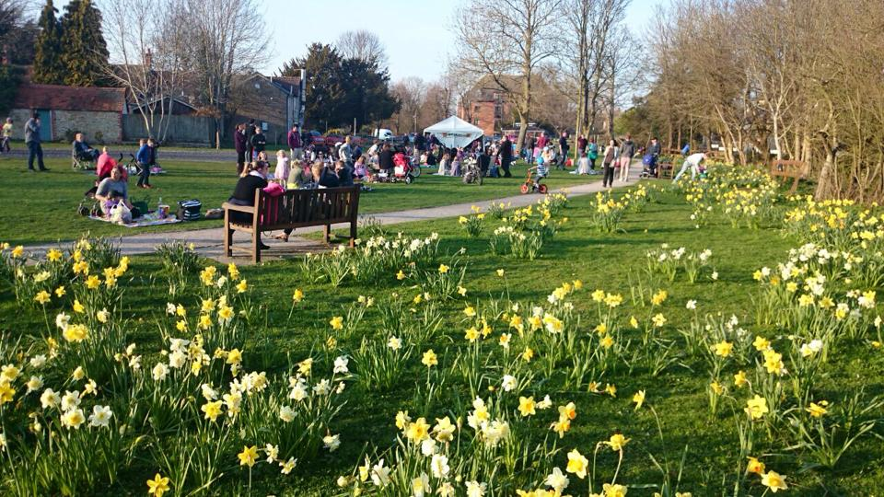

Monitoring and Review

The Town Council will deliver the projects/actions identified in this plan. Inevitably, new and unplanned demands will be made on the Town Council during the plan period. The list of projects will be monitored, and the Plan will be reviewed in full each year.

The requirement to respond to new demands will need to be balanced with available resources, and approval of new projects will inevitably require the displacement of agreed actions unless resources are increased.

This 5 Year Action Plan was approved by Full Council on 28th April 2025, minute no. 354

Signed: Date:

(Mayor of Gillingham)

